**Module 1 Homework Challenge**

1. Given the provided data, what are three conclusions that we can draw about crowdfunding campaigns?
   * Given the provided data, one can draw the following conclusions about crowdfunding campaigns:
     + The most successful campaigns tend to be related to Theater, Film & Video, and Music. This could be that due to the nature of the campaigns (live entertainment), people are more likely to attend the campaign events, thus more opportunity to pledge money.
     + The least successful campaigns, with the least number of successful campaigns and total number of backers, were related to Journalism. This could be due to the nature of the campaign being less entertaining or engaging, thus providing less opportunity and limited visibility.
     + For this specific dataset, the vast majority of crowdfunding campaigns took place in the United States, versus all the other countries (AU, CA, CH, DK, GB, IT).
2. What are some limitations of this dataset?
   * Some limitations of this dataset are some of the categories and subcategories may overlap with each other; for example Theater and Film & Video are very similar, and its possible that the individuals collecting the data may have misrepresented the campaigns’ true categories. Additionally, if the analyst wanted to take a closer look at the amounts funded by each campaign, it would be helpful to have access to the individual pledges received.
3. What are some other possible tables and/or graphs that we could create, and what additional value would they provide?
   * One could create additional graphs to show the overall campaign outcome by country to see which country is having the most success. This way one could also see if there is too much focus on a specific country and could tap into a strong market in other countries. For example, in this dataset the majority of campaigns took place in the United States. From the Extra Table #1 created in the end, one can see that Great Britain had an overall success rate of 58%, compared to the US which had a 57% success rate. The crowdfunding organizers could tap into Great Britain and expect to see success rates similar to, or better than those seen in the United States.

**Statistical Analysis**

1. Does the mean or median better summarize the data?

* The Median summarizes the data better in this dataset because the distribution is skewed (there are outliers present, and these are the high-dollar amount pledges).

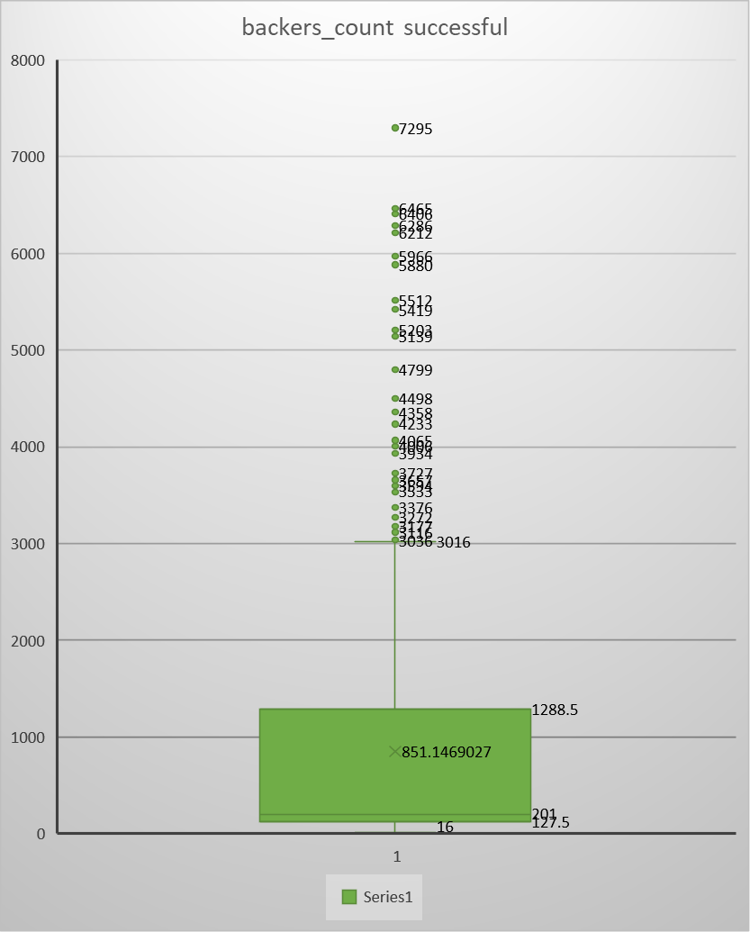

1. Is there more variability with successful or unsuccessful campaigns? Does this make sense? Why or why not?
   * There is more variability with unsuccessful campaigns because pledge amounts are less consistent, therefore making it more difficult to predict pledge goals and creating overall uncertainty and instability within the campaign.